Chapter 2 p.19

Breakdown of ransomware by variants

The top four variants comprised 65% of all ransomware encounters

Bar graph showing Breakdown of ransomware by variants. X-axis represents Magniber, Lockbit, Hive, Blackcat, DJVU/Stop, Basta, Darkbit, Fargo, Royal, Eight, Mazenote, Cartel, Skylock, Phobos, Mokop, BlackMatter, Cuba, Doppelpaymer, and the y-axis represents percentages from 0 to 25 in intervals of 5. Magniber shows approx. 20%, followed by Lockbit, Hive, and Blackcat showing approx. 8%. Other variants show negligible percentages. A pie chart depicting the top four variants comprised 65% of all ransomware encounters is also shown alongside.

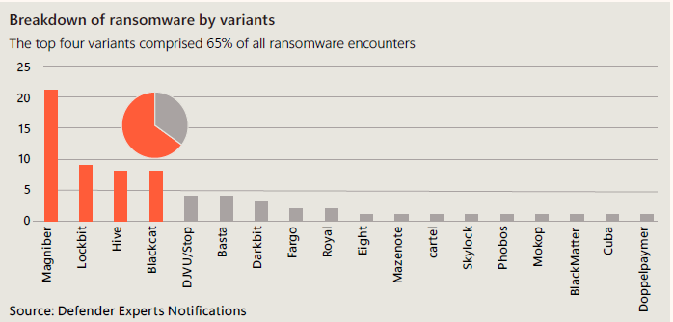

Source: Defender Experts Notifications